Date February 10, 2021
Place Virtual Zoom
Prayer Dominick Bucci, Chapter 2nd VP
Flag Salute Henry Youngster, Chapter Member
Dinner n/a
Meeting 7:04 pm

Members & Guests in Attendance
Members at meeting 22
Guests at meeting 0
Total (Roster is at 48) 22
Percentage at meeting 45%

Executive Board
Attendance at meetings 9/20 10/20 11/20 12/20 1/21 2/21 3/21 4/21 5/21 6/21
President: Eileen Wood
1st VP: Pat Ligouri x
2nd VP: Dominick Bucci
Secretary: Steve Pelonero
Treasurer: Bruce Ponchak
Sgt.At-Arms: Jim Minnella x x x

Delegates at meetings
1. Jean Chomko ☺ x
2. Joyce O’Hara ☺
3. Need one more x x x x x x

Board of Directors at meetings (6 past Chapter Presidents)
Carmen Gaita
Bruce Ponchak ☺
John Barbieri ☺ x
Bob Appaluccio ☺ x
Steve Pelonero ☺
Carmen Criscione x

Past Chapter Presidents in attendance at meetings
9/20 10/20 11/20 12/20 1/21 2/21 3/21 4/21 5/21 6/21
Joe Agresti PNP x x x x x
Bob Appaluccio ☺ x
John Barbieri ☺ x
Sal Benvenuti ☺
Carmen Criscione x
John Morano ☺
Steve Pelonero ☺
Bruce Ponchak ☺
Chuck Russo ☺ x
Angelo Verrone x x

Opening Remarks
- President Eileen Wood:
  - Eileen welcomed and thanked everyone for attending another meeting. She said that she was hopeful that we all get back soon to a normal venue.

- 1st VP Pat Ligouri:
  - Not in attendance.

- 2nd VP Dominick Bucci:
  - Dominick welcomed everyone.

Secretary Minutes
Secretary: Steve Pelonero
- Steve reported that the minutes were emailed to all chapter members as well as being on our chapter website.
- Motion to accept by:
1st John Barbieri
2nd Joe Benvenuti
All were in favor.

Treasurer Report
Treasurer: Bruce Ponchak
Bruce emailed the minutes to all chapter members.
- Motion to accept by:
1st Angelo Verrone
2nd Joe Benvenuti
All were in favor.

Chapter Budget
- No report.

Bills and Communications
- John Morano reported that we received two items in the mail:
  - A thank you from St. Jude’s in Memphis for our donation in memory of Arlene Agresti.
  - A packet from UNICO National to let us know that National Amendment Changes can be submitted for voting at the convention with the forms that were included.

Fundraising Committees
- Holiday Cheer: Bob Appaluccio
- No report.

- Food Pantry: Roni Corrado
  - Roni Corrado was pleased to announce that with the donations from our chapter members in lieu of the monthly meeting dinner costs, $525.00 was collected and distributed to two of our local food pantries. $225 was given in gift cards to St. James Church in Totowa. $300 was given to the Veterans of Passaic County.
  - Roni noted that the veteran pantry takes care of 87 veterans along with 47 children of their children. 30% of the veterans are disabled. Many of the returning veterans are also women. All the vets come home, some with no jobs available.
  - The veterans are also accepting furniture and clothes.
  - Roni said that gift cards sent to her are the best and easiest way to have our donations distributed.
  - Roni reported that the next two pantries that would be concentrated on are Holy Angels Church and St. Agnes Church both of which are in Little Falls.
  - If any member would still like to donate to out Food Pantry Committee, please continued to send your donation / gift cards to Roni’s home address.

- Overseas Soldier Program: Roni Corrado
- Henry Youngster reported that Joshua Tosi is home and now active with the National Guard

- Golf Outing: Joe Barone
- In Joe Barone’s absence, Joe Benvenuti reported that the golf outing is set for Monday, June 14th. The Meadows was the least expensive of the local courses.
- The outing will take place at the Meadows Golf Course in Lincoln Park with a 10 am tee time. More information will follow at another time.

- Community Service Day: Pat Liguori
- No report.

Non-Fundraising Committees
- Scholarship: Carmen Gaita
- Carmen reported that as of last months meeting when he asked that if anyone wanted to donate to the scholarship fund so that we can give more: We received in donations $1,150 extra. Thank you to those members.
- Currently we have in addition to the Brian Piccolo Awardees, we have three members with grandchildren who are eligible to apply for a $1,000 Scholarship from our chapter.
- There are no plans yet for a dinner, which normally would be held in June. It is still to close to tell what guidelines there will be due to the pandemic.
- Carmen reported that there will be, as also noted at last months January meeting, a $10 per ticket raffle 50/50. Tickets are given out individually instead of books of 5’s or 10’s.
- Carmen noted at this February meeting that no tickets will be mailed out to the members but that the committee hopes that everyone member contact him or Joe Benvenuti to have x-amount of tickets mailed to them. Steve Pelonero, Chapter Secretary, said that he would do an email blast to our members with Carmen and Joe’s contact information.
- The drawing is a 50/50 @ $10.00 at $10 a ticket, with a drawing date of May 21st.

- Italian Heritage: Angelo Verrone
- Angelo mentioned that he was thinking of how we could do a mini-Italian Heritage event. If anyone has an idea of a venue, please contact him.

- Italian Studies: Joe Agresti PNP
- No report
- Good and Welfare: Sal Nocella
- Sal Nocella reported that a Condolence card was sent to the John Alati family. John was a member of the Verona Chapter and was a UNICO Past National President. He was our current UNICO Foundation President.
- Sal also reported that another Condolence card was send to the Spano Family in Memphis TN. The mother of Mike Spano PNP, had passed.

- Membership: John Barbieri
- John reported that of our 48 members, our average age is at 72 years young. There are six chapter members celebrating their birthdays in February.

- Newsletter & Website: Steve Pelonero
- Steve reported that all was up to date on both the website and newsletter.
- Our website is at 86,256 as of February 10, which is up from Januarys at 86,200 visits.
- Not mentioned but to be noted is that all birthdays are listed on our chapter website calendar, along with our past monthly meeting minutes.

District and National Events
- District News
  - Eileen Wood reported that our District Governor Steve Calantone sent to us a Pequannock Chapter Auction Fundraiser Flier. For those that would like to support it please contact Eileen for more information.

- National News
  - Sal Benvenuti reported that the National Mid-Year Board meeting will be held via a zoom meeting on March 20. Pre-registration is needed. Without registering, you will not get the zoom link. This meeting is a required one for all the National Executive and Board of Directors. There will also be a foundation meeting at this zoom meeting.
  - Sal reported that in lieu of John Alati PNP’s death, that Chris DiMattio PNP, as VP of the Foundation, will move up to take Johns place as president of the Foundation.
  - Sal reported that every chapter did receive a packet advising that amendment changes can be recommended. The forms must be received for approval by April 13th.

Old Business
- No old business
New Business
- Eileen Wood (chapter president) asked everyone in attendance if they were up for a live and social distanced meeting at a church hall. Dominick Bucci (2nd VP) said he would book the date (2nd Wednesday of March 10th) at Holy Cross Church in Woodland Park. More information will follow. It was suggested that this be a BYO Coffee, with no food served or available.

Attendance at the February 10, 2021 Zoom meeting

The photo below represents those who were online at the zoom meeting at the time that the photo was taken at 7:40 pm. More could have been online before or after it was taken. 20 are shown but there were 22 in attendance.

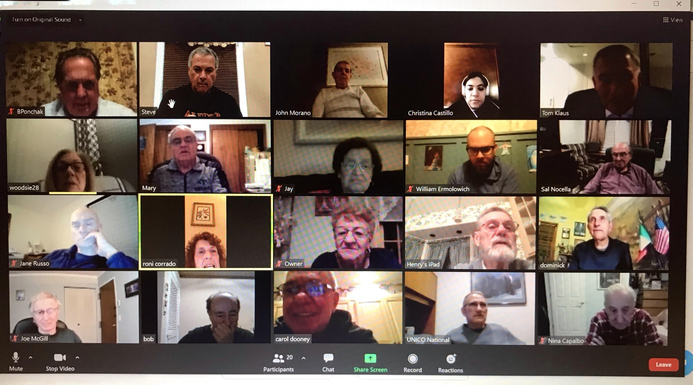

Continued on next page.

Attendance at this February 19th meeting:

1 | Bob | Appaluccio
2 | John | Barbieri
3 | Sal | Benvenuti
4 | Joseph | Benvenuti
5 | Dominick | Bucci
6 | Frank | Capalbo
7 | Christina | Castillo
8 | Pat | Corrado
9 | Roni | Corrado
10 | William | Ermolowich
11 | Carmen | Gaita Jr
12 | Joe | McGill
13 | John | Morano
14 | Salvatore | Nocella
15 | Joyce | O’Hara
16 | Steven | Pelonero
17 | Bruce | Ponchak
18 | Chuck | Russo
19 | Jay | Sisti
20 | Angelo | Verrone
21 | Eileen | Wood
22 | Henry | Youngster

Adjournment
Motion was made to adjourn @ 7:46 pm
- 1st Joe Benvenuti
- 2nd Bill Ermolowich
All were in favor.

Respectfully Taken by
Steve Pelonero, Chapter Secretary

